*Press Information Poznań, dn. 15.05.2025*

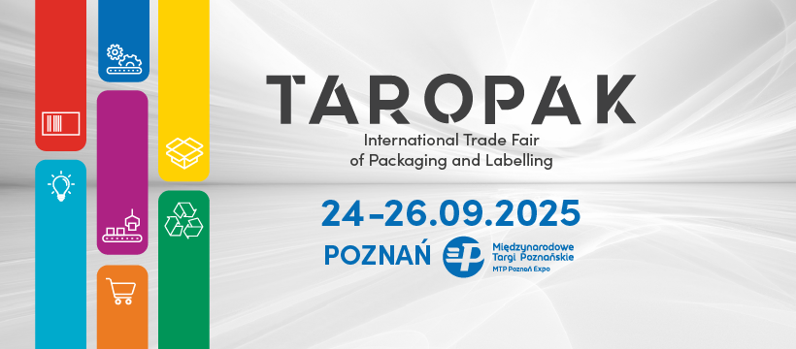

**TAROPAK is Gaining Momentum! The Trade Fair Returns This September**

**The International Trade Fair of Packaging and Labelling TAROPAK is changing its date: the next edition will take place from September 24–26, 2025, alongside the POLAGRA trade fair. As every year, the event will be held at the MTP Poznań Expo.**

The decision to reschedule TAROPAK was made to provide better conditions for building business relationships, showcasing innovative solutions to a wider audience, and strengthening connections across both the packaging and food industries.

This change also reflects market needs – nearly 70% of all packaging is destined for the food sector, for which September is an ideal time in terms of planning sales and marketing activities. The new date aligns better with the operational cycles of many companies that regularly participate in TAROPAK.

This year's edition will run concurrently with POLAGRA, a key event for Poland’s food industry, creating even more opportunities for networking and strengthening business relationships.

TAROPAK is one of the most comprehensive industry events, bringing together representatives from various sectors of the economy where packaging plays a vital role. At the MTP Poznań Expo, you’ll meet professionals from industries such as: food, cosmetics, pharmaceuticals, furniture, automotive, gardening, and many more.

The trade fair’s thematic scope covers a full range of solutions – from packaging machinery and packaging production equipment, through ready-made packaging products, to modern warehouse systems and innovative labels.

TAROPAK is not just an exhibition space – it’s a knowledge-sharing platform, a venue for inspiring discussions, and a place for product debuts that set the direction for the entire packaging industry.

Mark your calendars now for September 24–26, 2025, and we warmly invite you to participate in the next edition of TAROPAK!

More about TAROPAK 2025: [www.taropak.pl](http://www.taropak.pl)

**International Trade Fair of Packaging and Labeling**

**24-26.09.2025**

**MTP Poznań Expo**