*Press Information Poznań, 04.11.2024*

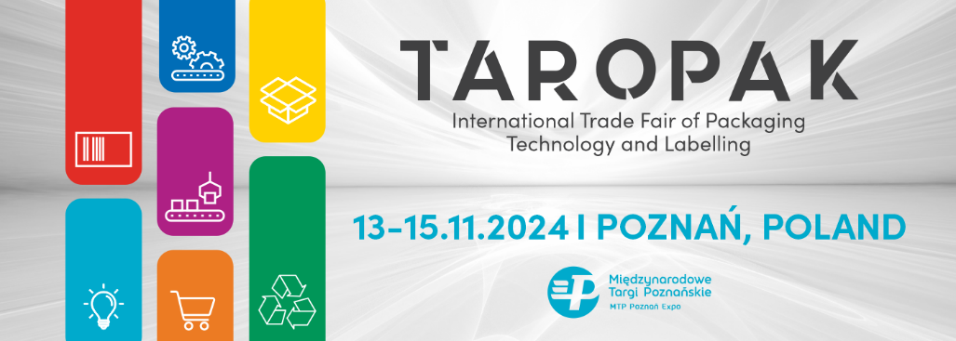

**TAROPAK 2024 – presenting market innovations, discussion panels, and meetings of packaging industry leaders**

**The International Trade Fair of Packaging Technology and Labeling TAROPAK is the most comprehensive event in Poland, covering all sectors of the packaging industry. Every edition introduces hundreds of innovations that serve industries reliant on packaging and labeling technologies. This year's TAROPAK, unveiling in a fresh format, will be held from November 13-15, 2024, at the MTP Poznań Expo.**

Every year, TAROPAK attracts a wide range of industries—from food, cosmetics, and pharmaceuticals to furniture, automotive, chemical, and horticultural sectors—all looking for innovative, functional solutions for product packaging.

**What's New at the Fair**

This year’s edition will showcase familiar industry solutions with a fresh twist. The exhibition will feature distinct packaging industry segments, including packaging materials, packing and manufacturing machinery, e-commerce packaging, and labeling technologies. Each area will be color-coded for easy navigation through the fairgrounds.

The first day will conclude with a panel discussion titled “Women in Packaging”, the first event in Poland to spotlight the role of women in the packaging sector. Topics will cover generational change, organizational culture, the influence of younger female leaders, and shifting customer awareness and behavior in packaging. The discussion will also explore trends in both Poland and abroad, with a focus on sustainability. This panel will be led by Marek Kich, CEO of Satisfly, with speakers including Monika Poprawa, CEO of greenopack, Dominika Dukiewicz, Production Director of POPRAWA P.S.A., and Beata Pyś-Skrońska, Director of the Polish Chamber of Packaging (Polska Izba Opakowań).

**Attending Industry Leaders**

This year, TAROPAK is set to welcome leaders from Polish and European companies. Attendees will include CEOs, packaging directors, maintenance engineers, quality control managers, and purchasing directors from many top brands. Representatives from industries like furniture and decor, as well as leaders from food, cosmetics, pharmaceutical, photography, computing, and horticulture sectors, have confirmed their attendance. Building equipment and power tool producers will also be present.

**TAROPAK E-COMMERCE**

A key focus for this year's edition will be the rapidly expanding e-commerce sector. The popular TAROPAK E-COMMERCE Conference returns, promising an exciting program with experts and leaders from the e-commerce world. Topics will include new packaging technologies, brand building, customer experience, logistics and supply chain efficiency, cost optimization, and packaging industry improvements. Smurfit Westrock, a global leader in sustainable packaging, is the conference's strategic partner, bringing the latest e-commerce solutions for everyday applications.

**Conferences and Discussion Panels**

In addition to showcasing market innovations, TAROPAK offers engaging meetings and panels. On the opening day, the Polish Chamber of Packaging (Polska Izba Opakowań), together with the Polish Chamber of Packaging Recovery and Recycling (Polska Izba Odzysku i Recyklingu Opakowań), will host a discussion on “Creativity and Responsibility: Eco-Design in a Circular Economy”, with speakers such as Dr. Prof. Renata Dobrucka of UEP, Konrad Nowakowski, President of the Polish Chamber of Recovery and Recycling of Packaging, and Krzysztof Niczyporuk, President of the Polish Chamber of Packaging.

Another compelling event is the panel “Deposit System: Challenges for the Industry and Local Governments. How to Balance Different Perspectives?” as the introduction of a deposit system is a topic of growing concern among stakeholders, including retail chains and local governments, who view the proposed changes as fast-paced and costly. The delay in implementation provides time for discussion and compromise. Organized by Łukasiewicz – Poznań Institute of Technology, this panel aims to foster dialogue to develop new agreements.

On the third day, in collaboration with the Polish Chamber of Flexographers (Polska Izba Fleksografów), TAROPAK will host a panel on “Flexography in Packaging. The Perfect Match.” Speakers will include Krzysztof Skrobot, President of the Polish Chamber of Flexographers, Marcin Kuchniak from AWEXIM Sp. z o.o., and Michał Wójcik from Zespół Szkół im. Joachima Lelewela w Poznaniu (the Joachim Lelewel Vocational School in Poznań).

For years, TAROPAK has brought together the packaging industry, facilitating the exchange of experiences, building lasting business connections, and introducing market trends and innovations.