*Press Information* Poznań, 24.10.2024

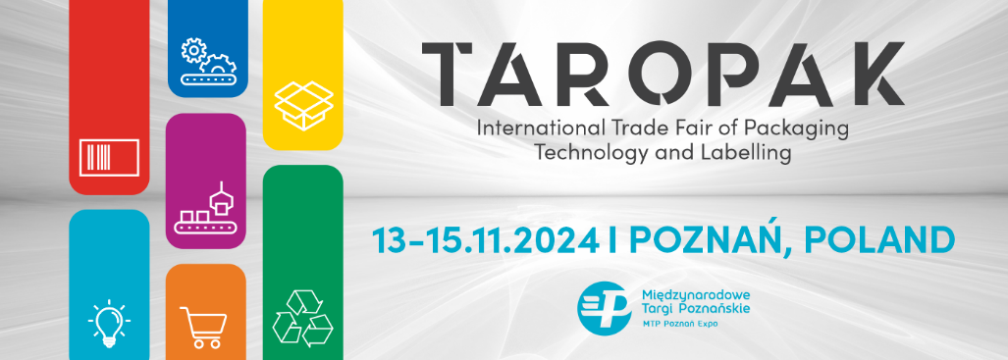

**Announcing the TAROPAK Trade Fair Event Program**

Three days of exhibitions, panel discussions, business and industry meetings, an awards gala, and a Networking Party – the event lineup for this year’s TAROPAK Trade Fair is now live.

TAROPAK is the most comprehensive packaging trade fair. In Poznań, representatives from industries utilizing packaging and labeling technologies come together. Attendees include representatives from the food industry as well as sectors such as cosmetics, pharmaceuticals, furniture, construction, horticulture, automotive, logistics, printing, and advertising. A significant focus will also be on the rapidly growing e-commerce market.

**13.11.2024**

On the first day of the TAROPAK, join the panel discussion "Creativity and Responsibility: Eco-Design in the Circular Economy”, organized by MTP Grupa and the Polish Chamber of Packagingm (Polska Izba Opakowań). Speakers include dr. Prof. Renata Dobrucka (UEP), Konrad Nowakowski (President of Polska Izba Odzysku i Recyklingu Opakowań), and Krzysztof Niczyporuk (President of the Polish Chamber of Packaging).

Later, attend the session on the deposit-return system: What challenges do entities involved in the system face? What are the associated risks, and when will it be introduced? How can new technologies support and improve this system? Experts from the Poznań Institute of Technology, the event’s co-organizers, will address these questions.

The day will conclude with the "Women in Packaging" discussion panel, the first Polish event dedicated to the role of women in the packaging sector. Topics include generational changes, organizational culture in the packaging industry, the influence of younger women on packaging markets, consumer behaviors, and sustainability initiatives in Poland and abroad.

**14.11.2024**

A highlight of Day 2 will be the TAROPAK E-COMMERCE Conference, bringing together e-commerce experts and leaders. Key sessions include new packaging technologies, brand building, customer experience, and logistics optimization.

On the same day at 5:00 PM, the TAROPAK Gold Medal Awards and the Acanthus Aureus Awards will be presented. After the gala ceremony, a Networking Party will take place.

**15.11.2024**

The third and final day focuses on flexography, with the panel "Flexography in Packaging: The Perfect Match," organized with the Polish Chamber of Flexography (Polska Izba Flskografii). Speakers include Krzysztof Skrobot (President, Polish Chamber of Flexography), Marcin Kuchniak (AWEXIM Sp. z o.o.), and Michał Wójcik (Joachim Lelewel Vocational School, Poznań).

All events will be held on the main stage in Aleja Lipowa.

More details on the event program are available at <https://taropak.pl/en/events-program/>

Free tickets are available until October 31 – simply complete the registration form. Details at <https://taropak.pl/en/news/take-part-in-taropak-2024/>

More information about TAROPAK is available at <https://taropak.pl/en/>