*Press Information Poznań, dn. 02.12.2024 r.*

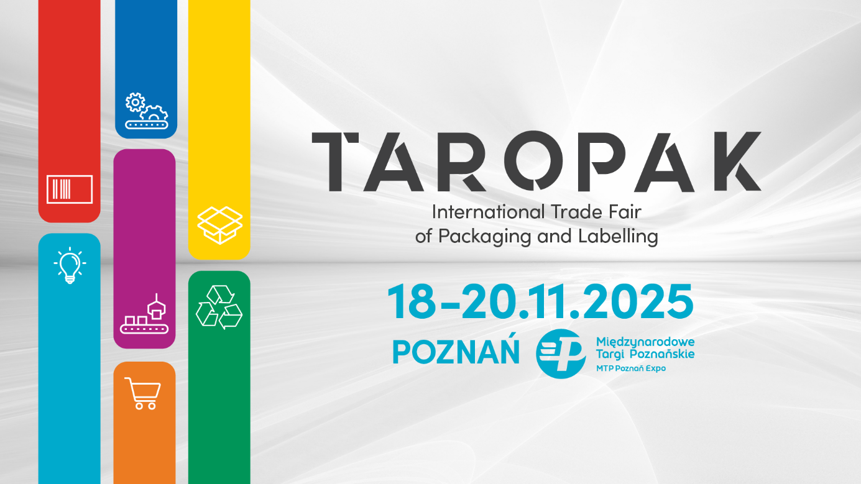

**The next edition of the TAROPAK International Trade Fair of Packaging and Labeling will take place on November 18-20, 2025.**

TAROPAK is a specialized and comprehensive event dedicated to all sectors of the economy that utilize packaging in their daily operations. Held at the MTP Poznan Expo, the event gathers representatives from industries such as food, cosmetics, pharmaceuticals, furniture, automotive, gardening, and many more.

TAROPAK features a wide range of exhibitors—from manufacturers of packaging machines and production equipment to producers of ready-to-use packaging suitable for various sectors, as well as suppliers of advanced warehousing solutions and innovative label producers.

TAROPAK is not just about a cutting-edge exhibition. It also includes the TAROPAK E-COMMERCE Conference, engaging panel discussions addressing current trends and challenges in the packaging market, and business meetings with industry leaders.

**Join us at the MTP Poznań Expo, where the future of Poland's packaging industry is shaped!**

Więcej o Targach TAROPAK 2025: [www.taropak.pl](http://www.taropak.pl)

**International Trade Fair of Packaging and Labeling**

**18-20.11.2025**

**MTP Poznań Expo**