*Press Information Poznań, 16.9.2024 r.*

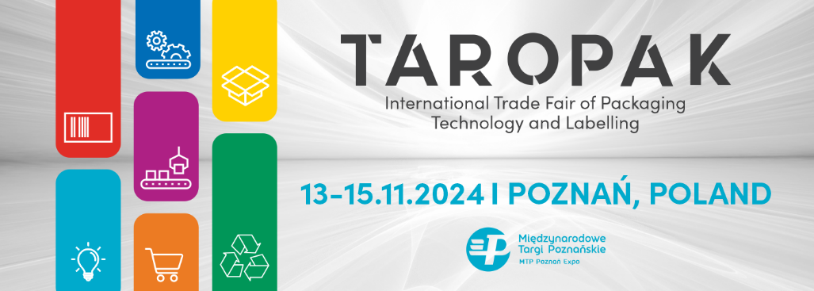

**TAROPAK – New Date, New Opportunities, and a New Format**

TAROPAK is a comprehensive trade fair covering all sectors of the packaging industry. Each edition of the event presents hundreds of innovations applicable across various fields of the economy where packaging and labeling solutions are utilized. The upcoming edition of the TAROPAK Fair, presented in a completely new format, will take place on November 13-15, 2024, at the MTP Poznan Expo.

Each year, TAROPAK attracts representatives from various industries – from food, cosmetics, and pharmaceuticals to furniture, automotive, chemical, and gardening sectors. All are seeking modern and functional solutions for packaging their products. A key focus of the fair is the rapidly growing e-commerce market.

**What's New at the Fair**

This year's edition of TAROPAK will feature well-known industry solutions, categorized by different sectors of the packaging industry, including raw materials and packaging materials, eco-packaging, packaging machines and equipment, e-commerce packaging, labeling, and warehousing. All zones will be color-coded to make it easy for visitors to navigate the exhibition space.

For the first time in the Polish packaging trade fair market, there will be a **Start-Up Zone** debuting at the upcoming TAROPAK Trade Fair. This innovative space will showcase pioneering projects, offering young entrepreneurs a chance to shine and providing companies with the opportunity to discover modern solutions and products that can significantly improve their day-to-day operations.

**TAROPAK E-COMMERCE Conference**

This year’s fair will once again host the popular TAROPAK E-COMMERCE Conference, featuring exciting topics and new speakers. During the sessions, participants will delve into issues related to new packaging technologies, brand building and customer experience, as well as efficient logistics

and supply chain management. Discussions will also cover cost optimization and improving efficiency in the packaging industry.

The strategic partner of the Conference is Smurfit Westrock, a global leader in paper production and sustainable packaging. The company operates in 40 countries, employing over 100,000 people across more than 500 packaging production plants and 63 paper mills. Thanks to Smurfit Westrock, conference participants will be able to learn about the latest solutions supporting e-commerce in everyday operations. The Conference will be held only in Polish language.

For years, TAROPAK has been connecting the packaging industry, facilitating the exchange of experiences, establishing lasting business relationships, and exploring market trends and innovations.

TAROPAK is a space that brings together various industries focused on modern yet functional packaging.

Learn more about TAROPAK 2024: [www.taropak.pl/en](http://www.taropak.pl/en)

**International Trade Fair of Packaging Technology and Labelling  
November 13-15, 2024  
MTP Poznan Expo**